>got to C:\Program Files (x86)\Arduino\hardware

>create folder espressif/esp32

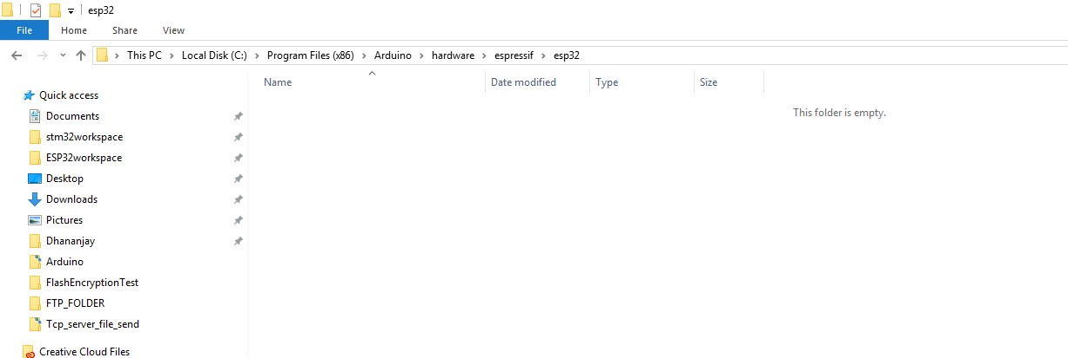

>open git bash as administrator (if dont have git install it from here <https://git-scm.com/downloads>)

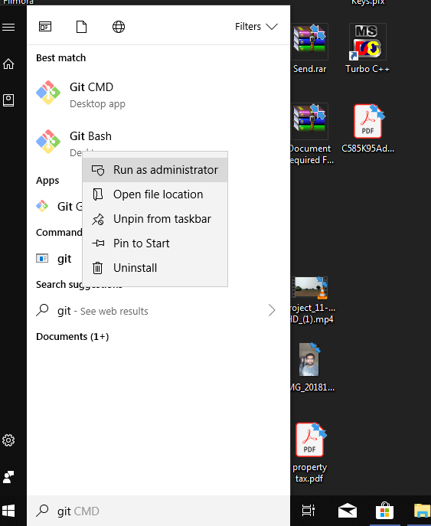

>navigate to Arduino/hardware/espressif/esp directory

cd "C:\Program Files (x86)\Arduino\hardware\espressif\esp32"

>give git command

git clone <https://github.com/espressif/arduino-esp32.git>

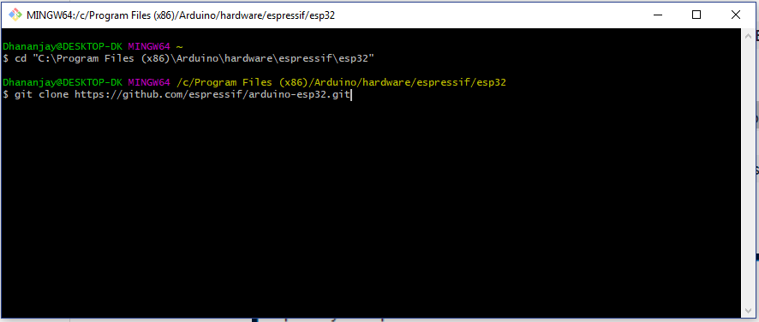

>Download will start

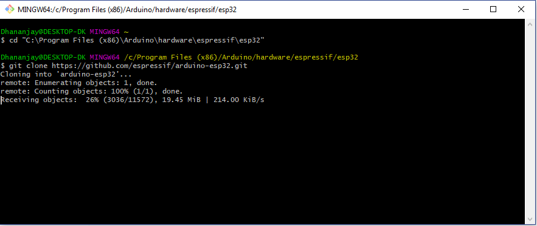

>after all download got to folder

C:\Program Files (x86)\Arduino\hardware\espressif\esp32\tools

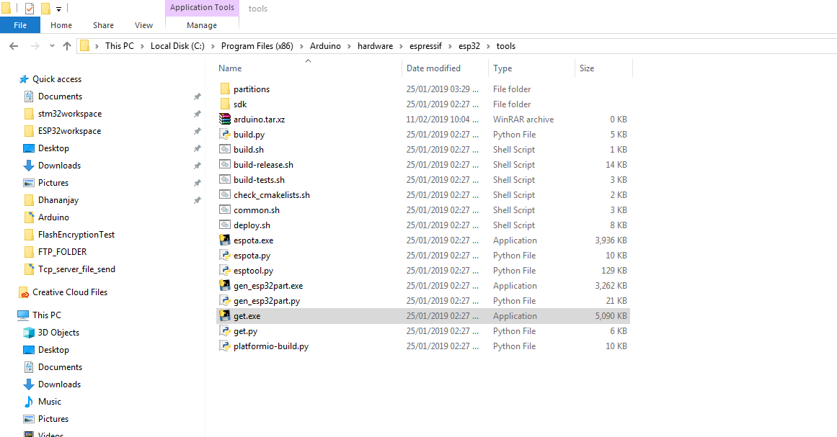open get.exe file. wait for download it.

>Use this board and setting to flash program

